HSLS GWAS Template Instructions

Here are the guidelines for running the GWAS template provided by the Health Sciences Library System for the All of Us Researcher Workbench. Carefully review each step in this document. Upon completion, you’ll have everything you need to carry out a basic Genome Wide Association Study using the All of Us short-read Whole Genome Sequence (srWGS) data, focusing on the Hail Exome subset.

**Step 1: Upload the Template to Your Workspace**

[Upload the template](https://support.researchallofus.org/hc/en-us/articles/360042684051-Are-external-coding-files-able-to-be-imported-for-analysis-) to your workspace before continuing to the next steps.

**Step 2: Create Your Cohorts and Datasets**

Create your final phenotype dataset for analysis. It should include the **outcome** **variable**, the **adjustment variables**, and the **person id** for each participant in your cohort.

**Step 3: Save the Final Phenotype Dataset to Your Workspace**

Save the final phenotype dataset to your workspace **as a tsv file** [*Figure 1*]. This is so it can be imported correctly in the GWAS template.

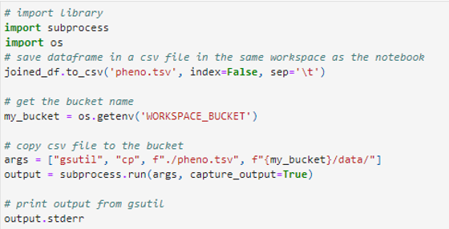

Figure 1: An example of Python code for saving phenotype data to the user's workspace.

**Step 4: Create Appropriate Cloud Environment for Genomic Analysis**

Before opening the template in your workspace, make sure you are working in the **Dataproc cluster** [*Figure 2*]. The default is the Standard VM, which will cause the template to crash.

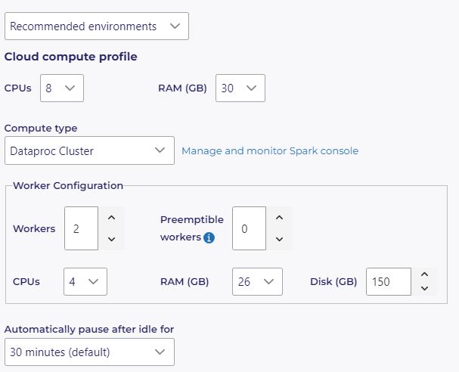

Figure 2: The cloud compute profile for genomic analysis in All of Us highlighting the Dataproc cluster as compute type.

**Step 5: Edit the Appropriate Fields in the Template**

Once you are in the template notebook, go to the designated cells for editing and input the correct information. Each section that can be edited is clearly marked with “### PLEASE EDIT THIS SECTION ###” so users know where changes can be made [*Figure 3*]. Cells that can be edited are located under the following sections: **Import Phenotype Data**, **Pulling Specific Regions of the Genome**, **MAF**, **Hardy-Weinberg Equilibrium**, **Linear Regression**, and **Stratification.**



Figure 3: An example of a cell that can be edited in the GWAS template, located under the **Import Phenotype Data** section.

**Step 6: Run the Template!**

Run all the cells. This will take a while, so you may want to run the notebook in the background.